HOW TO DOWNLOAD AND INSTALL MYSQL
To download MySQL installer, go to the following link http://dev.mysql.com/downloads/installer/
Once you click the link, it’ll bring you to the image below. You may also copy and paste on a browser.

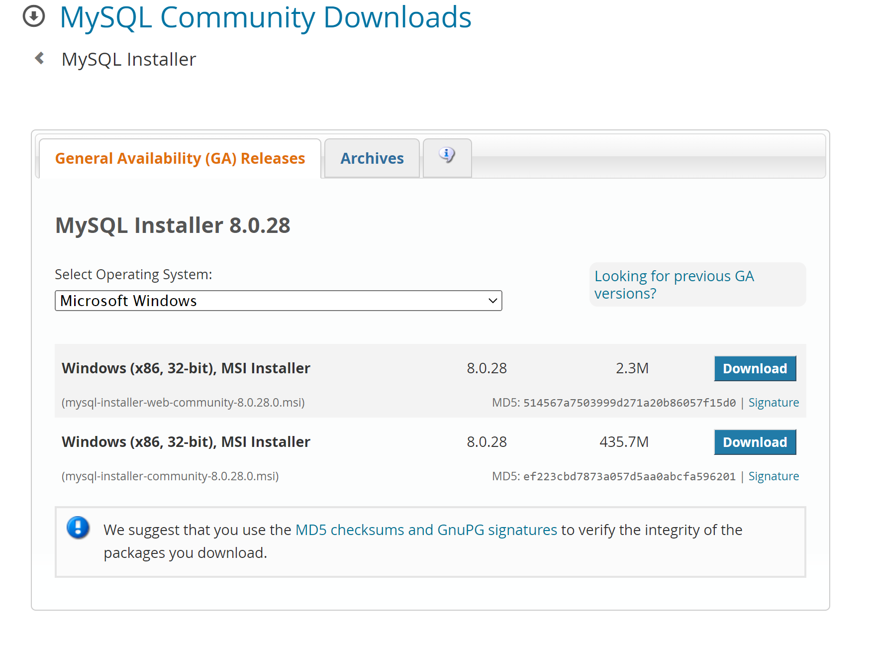

Install MySQL via MySQL Installer
To install MySQL using the MySQL installer, double-click on the MySQL installer file and follow the steps below:
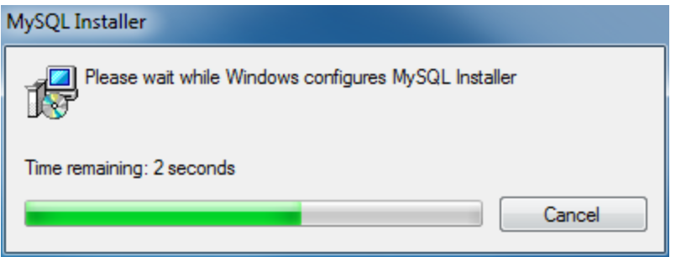
Install MySQL Step 1: Windows configures MySQL Installer
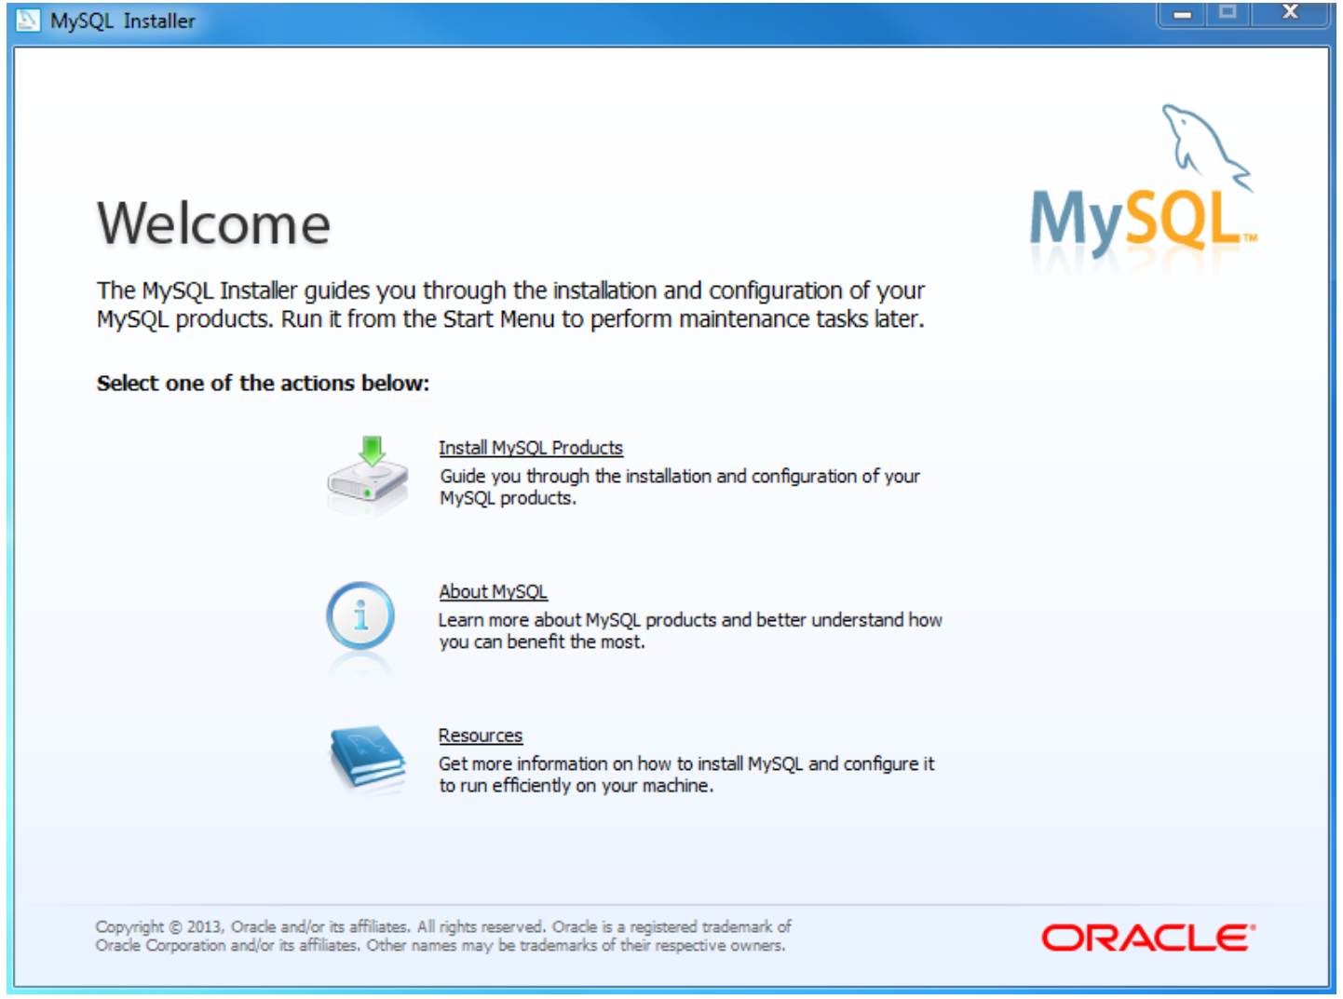

Install MySQL Step 2 – Welcome Screen: A welcome screen provides several options. Choose the first option: Install MySQL Products
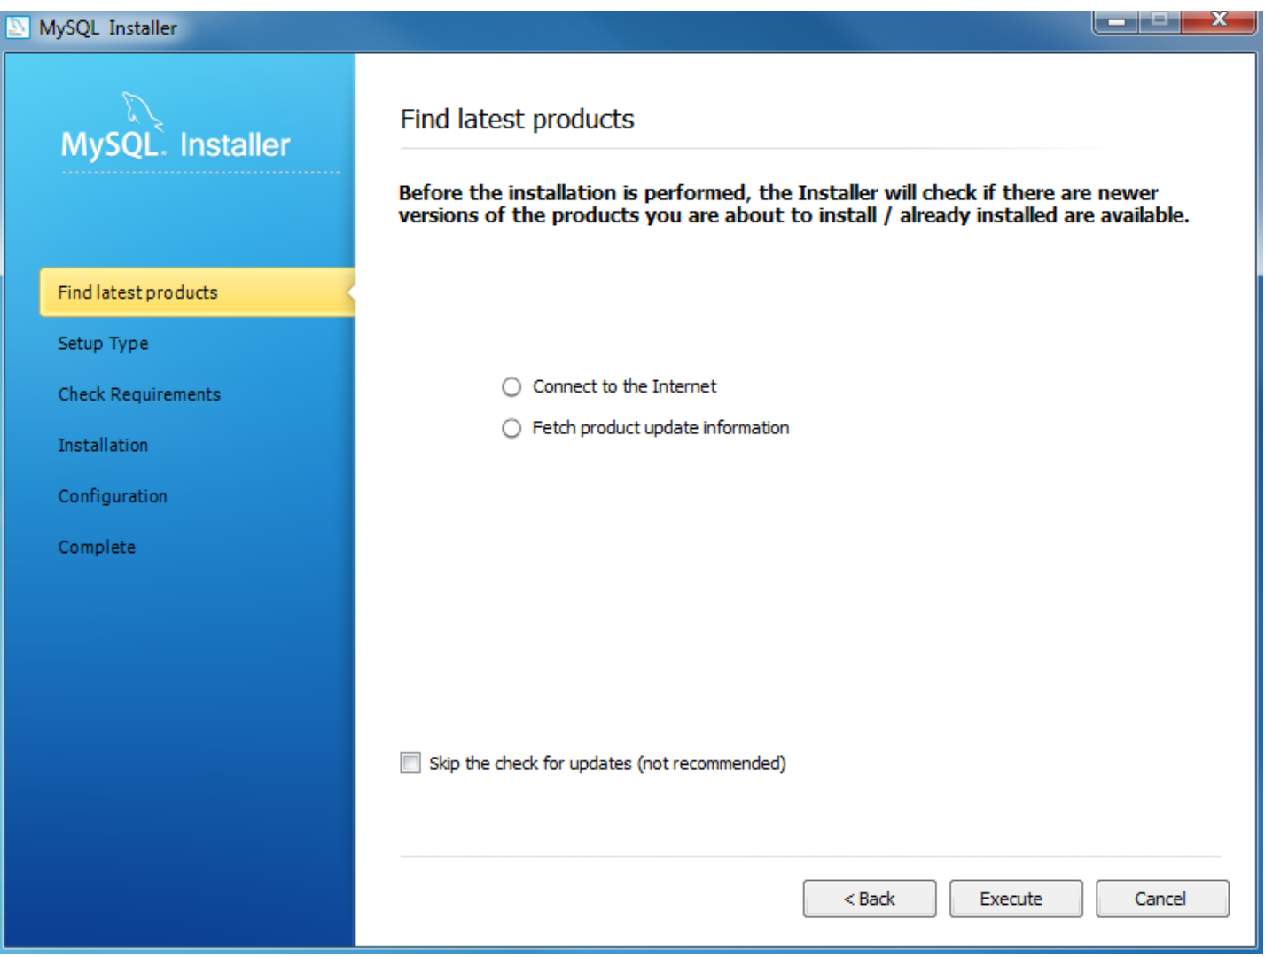
Install MySQL Step 3 – Download the latest MySQL products: MySQL installer checks and downloads the latest MySQL products including MySQL server, MySQL Workbench, etc.
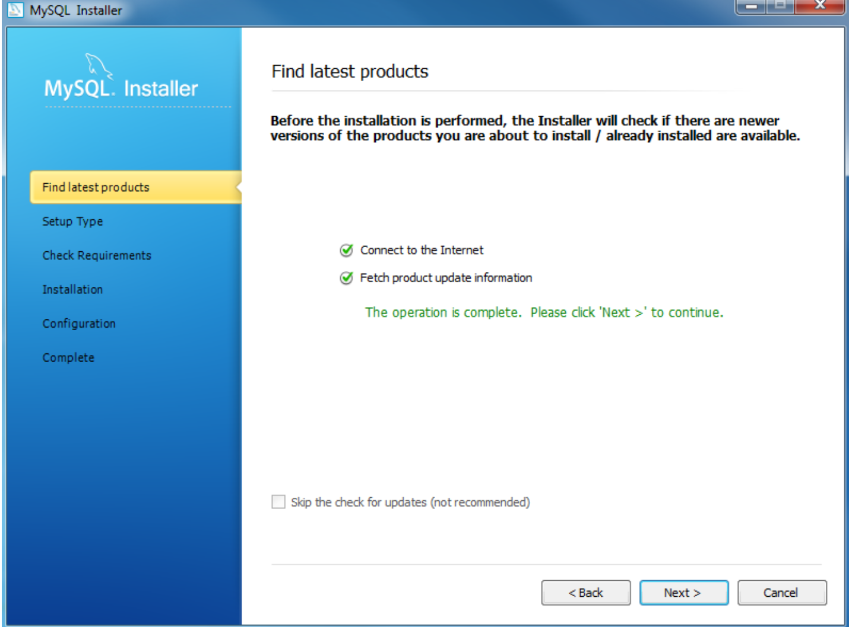
Install MySQL Step 4: Click the Next button to continue
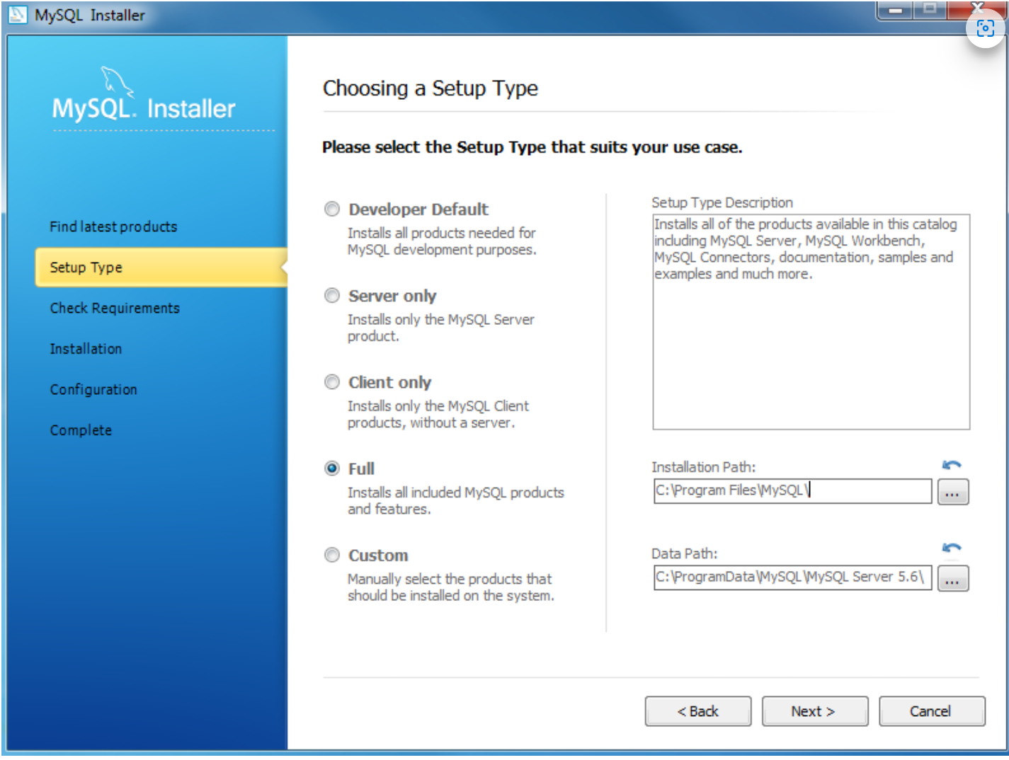
Install MySQL Step 5 – Choosing a Setup Type: there are several setup types available. Choose the Full option to install all MySQL products and features.
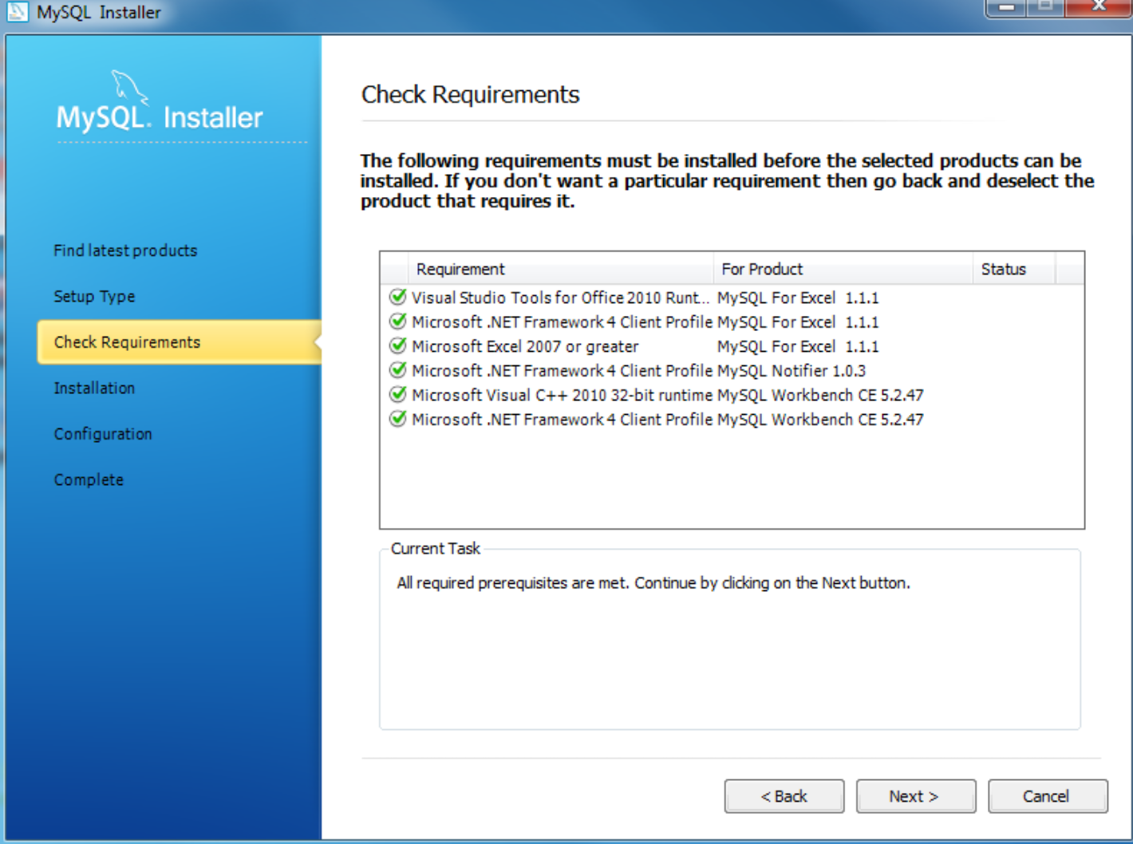

Install MySQL Step 6 – Checking Requirements
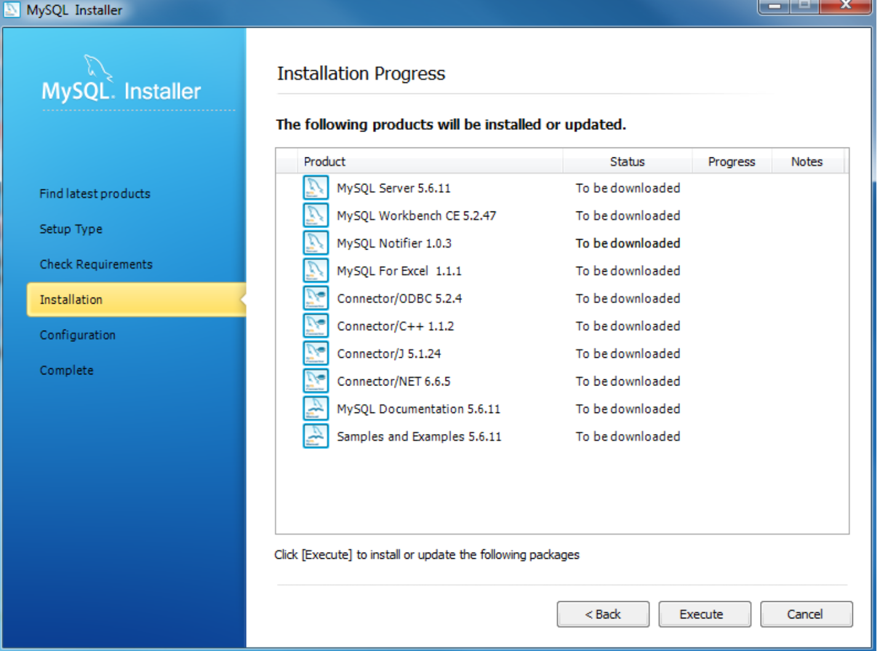
Install MySQL Step 7 – Installation Progress: MySQL Installer downloads all selected products. It will take a while, depending on which products you selected and the speed of your internet connection
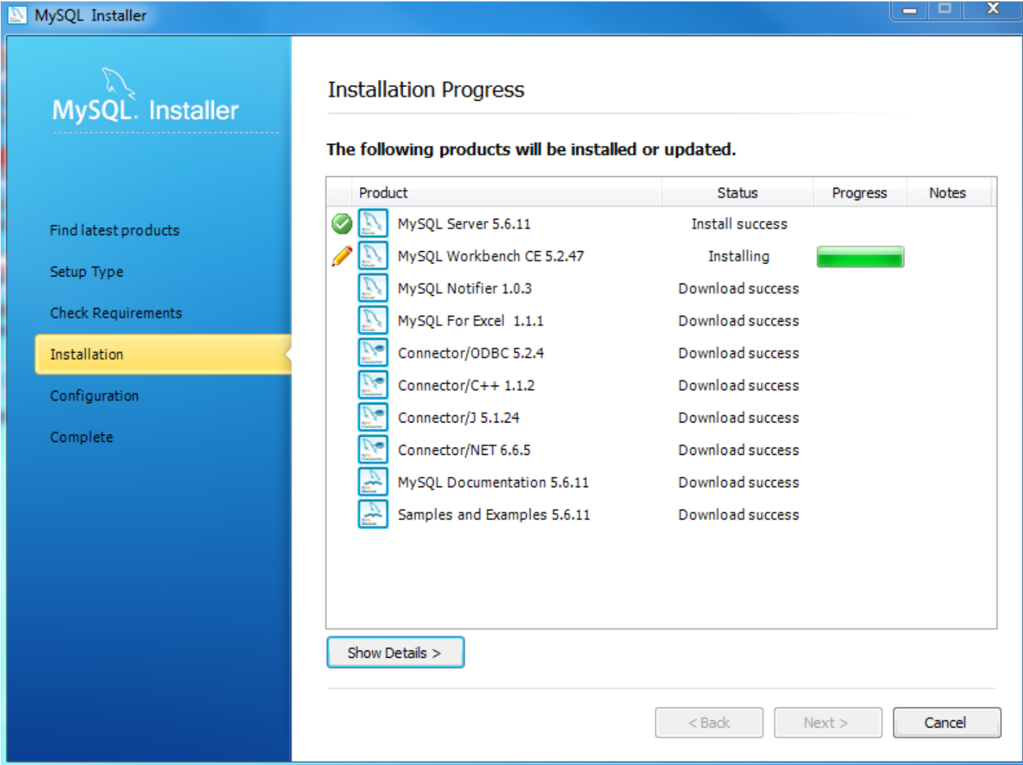
Install MySQL Step 7 – Installation Progress: downloading Products in progress.
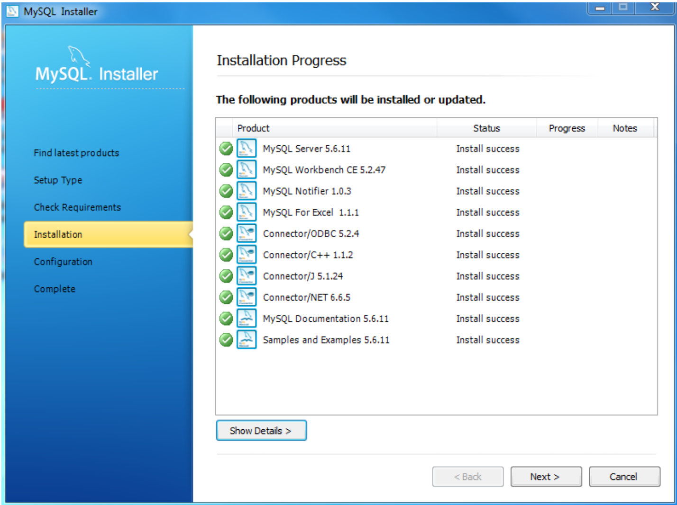
Install MySQL Step 7 – Installation Progress: Complete Downloading. Click the Next button to continue…
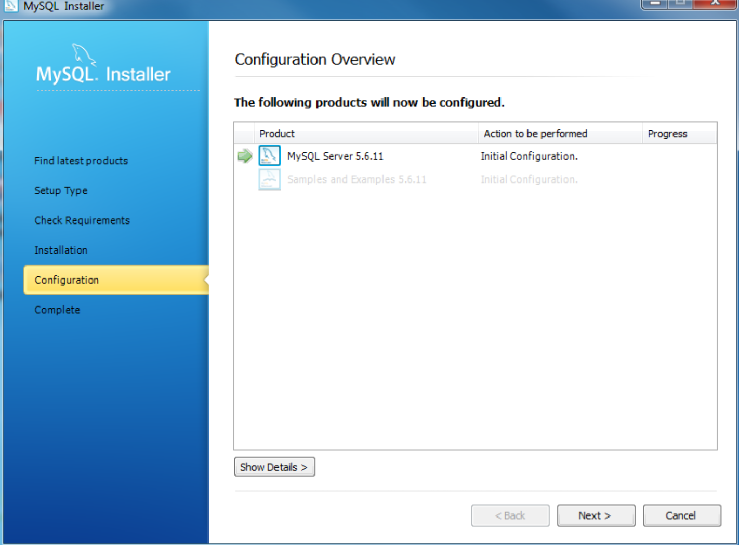

Install MySQL Step 8 – Configuration Overview. Click the Next button to configure MySQL Database Server
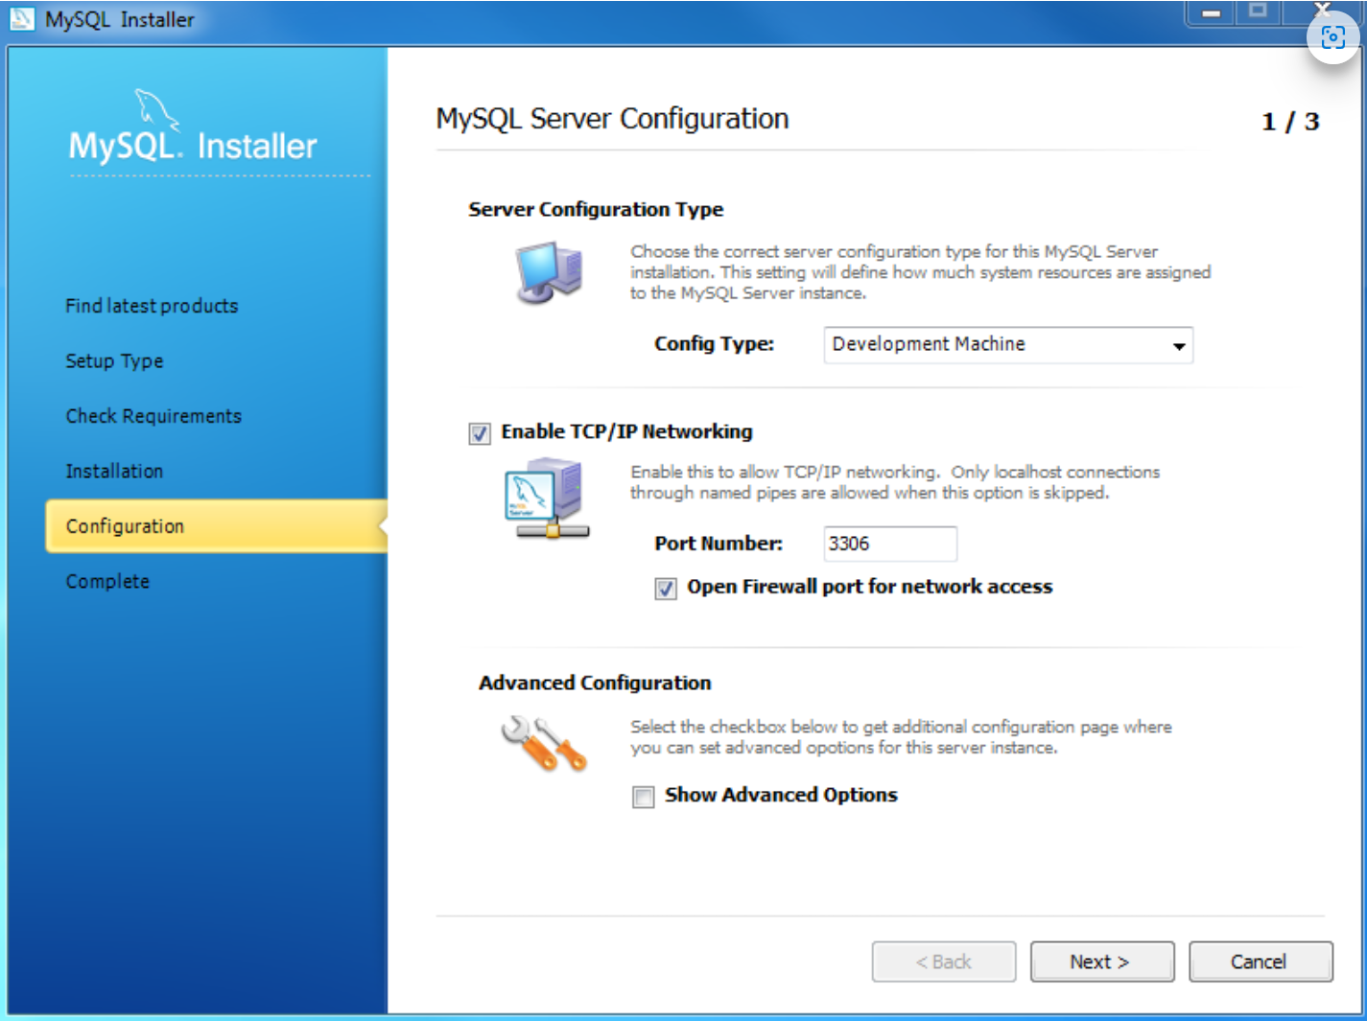
Install MySQL Step 8.1 – MySQL Server Configuration: choose Config Type and MySQL port (3006 by default) and click Next button to continue.
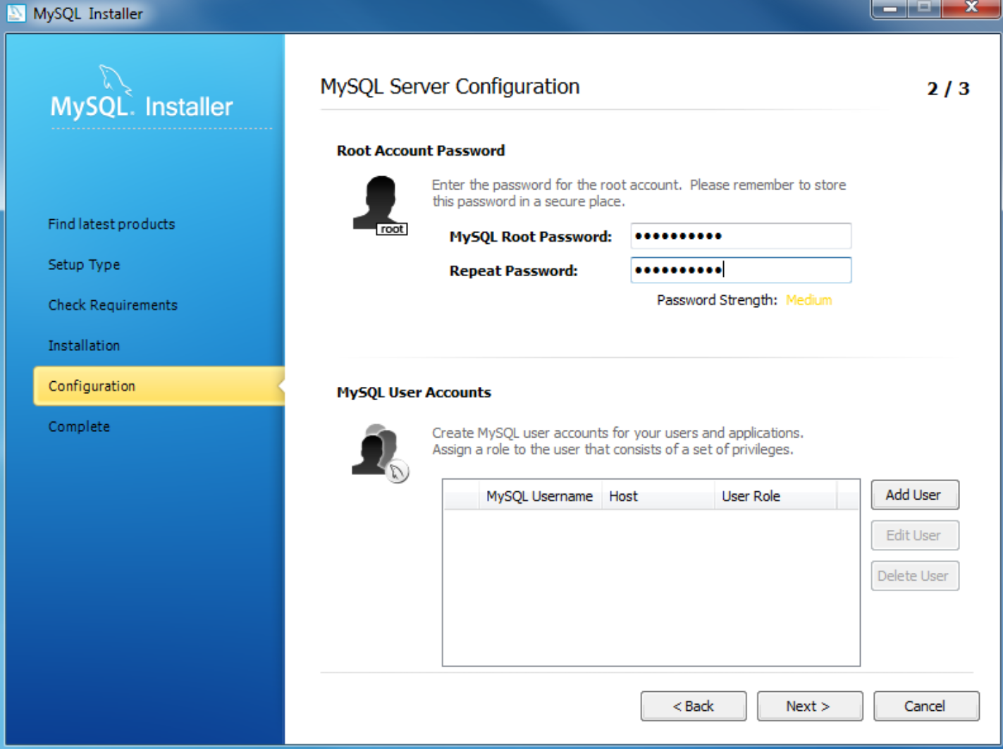

Install MySQL Step 8.1 – MySQL Server Configuration: choose a password for the root account. Please note the password download and keep it securely if you are installing MySQL database server on a production server. If you want to add a more MySQL user, you can do it in this step.
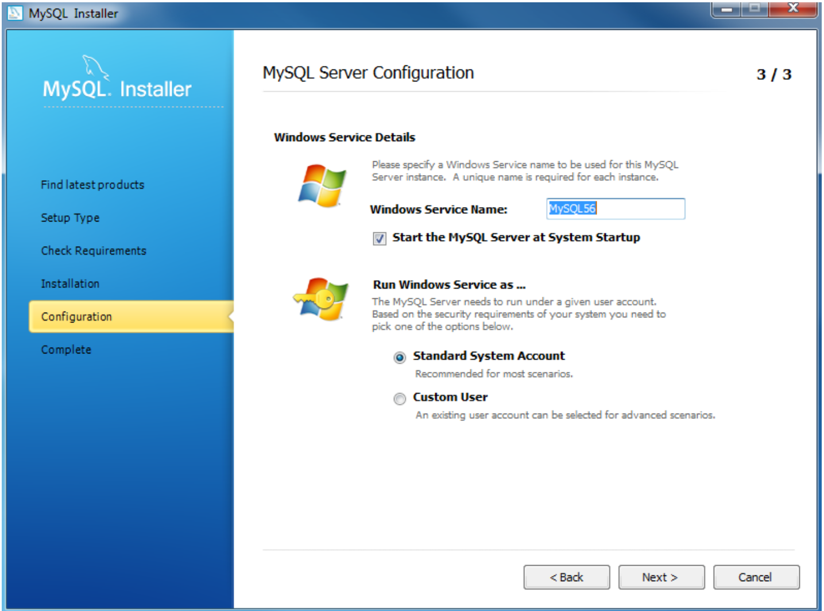
Install MySQL Step 8.1 – MySQL Server Configuration: choose Windows service details including Windows Service Name and account type, then click Next button to continue.
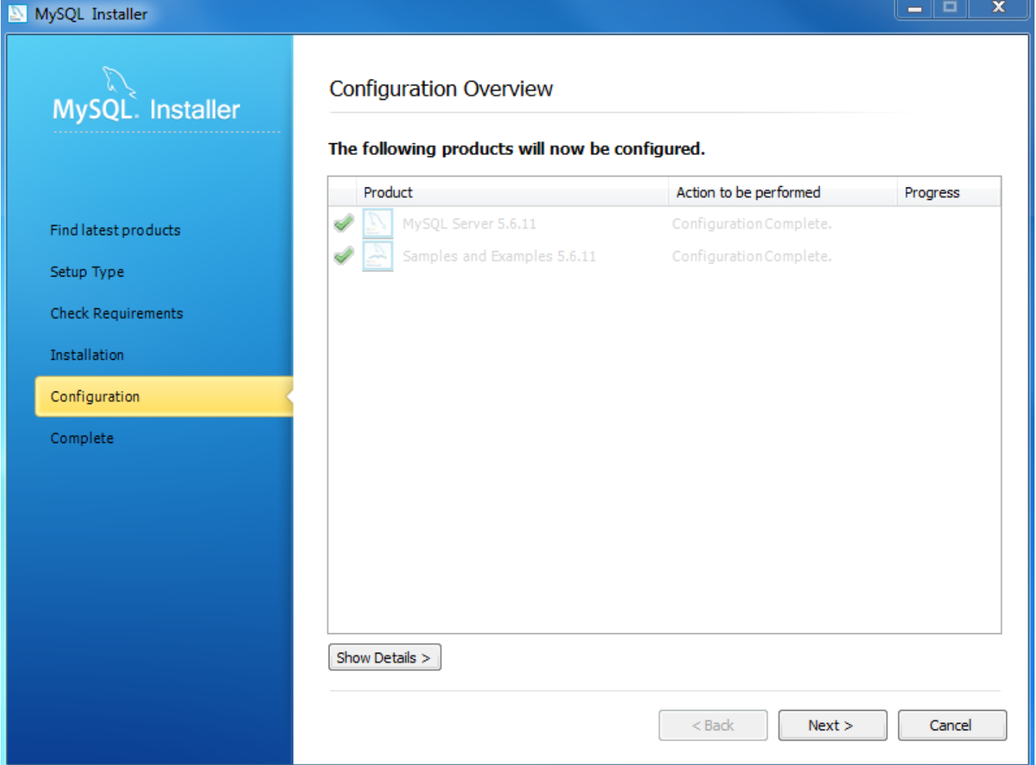
Install MySQL Step 8.1 – MySQL Server Configuration – Done. Click the Next button to continue.
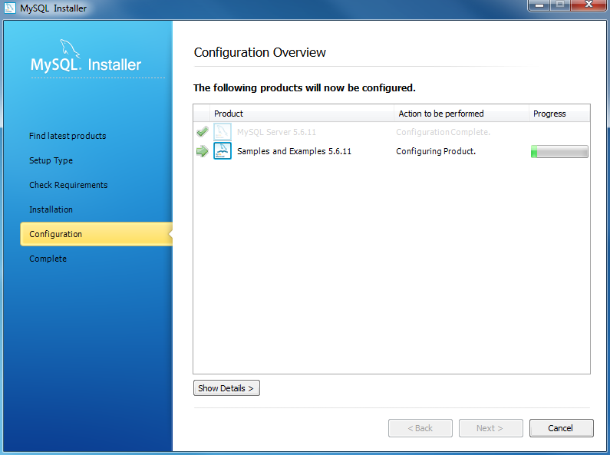
Install MySQL Step 8.2 – Configuration Overview: MySQL Installer installs sample databases and sample models.
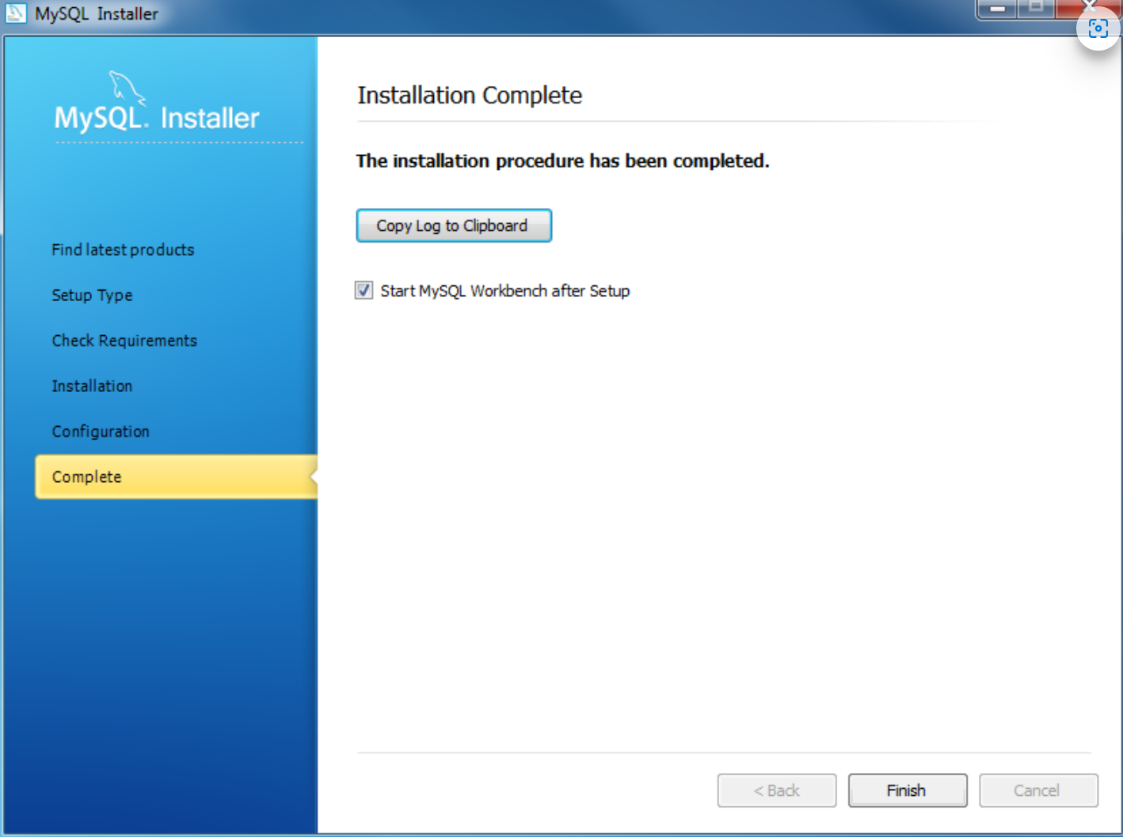
Install MySQL Step 9 – Installation Completes: the installation completes. Click the Finish button to close the installation wizard and launch the MySQL Workbench.
In this tutorial, you have learned how to install MySQL on your Windows system using the MySQL installer.

